TrueView Site Plan

Dylan Davis

WDD 130

Overview

Purpose
Bring honest and open ratings of entertainment media; mainly movies, shows, and games to the public.

Audience
Parents or anyone who is cautious about the media.

Branding

Website Logo
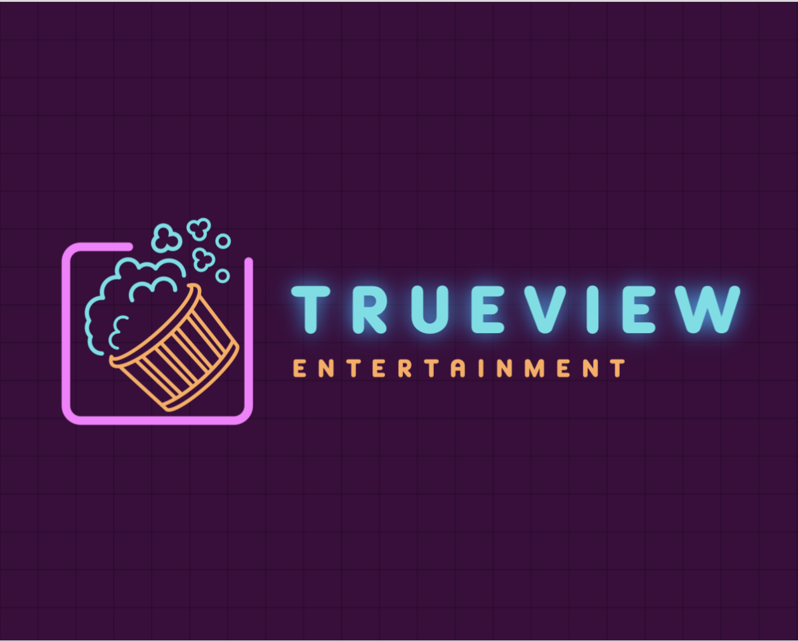

Style Guide

Color Palette
Primary | Secondary | Accent 1 | Accent 2
#5be0e6 | #ffab59 | #ff78ff | #3c0a3c

Typography

Heading Font: INLANDERS

Paragraph Font: Coolvetica

Navigation
Home Guides Movies Shows Games Actors About

Content

TrueView – See Media Clearly
In today’s world, movies, shows, and video games can surprise you—and not always in a good way. A harmless-looking family movie suddenly drops a scene you weren’t expecting. A suspense show turns out to be a jumpscare factory. A game rated “Teen” feels a little too intense for actual teens.
TrueView exists to eliminate those blind spots.
We believe every viewer deserves to know exactly what they’re watching before they hit play. No vague rating labels. No guessing. No unexpected content that ruins the experience or makes you regret your choice. Just full transparency, presented in a clear and human-centered way.

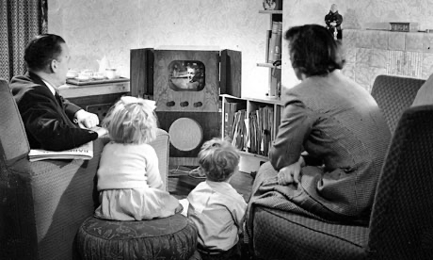

Why TrueView Matters
Entertainment is supposed to be… well, entertaining. Not stressful. Not confusing. TrueView helps you confidently choose content that fits your comfort level, your mood, and your audience—whether that’s kids, adults, friends, or the one person who definitely can’t handle horror.
We break things down in everyday language, designed for real people—not insiders or critics. Our goal is to empower you with clarity, not overwhelm you with jargon or judgment.

What You’ll Find on TrueView

Real Ratings
Every title on TrueView includes a simple breakdown of why it received its rating. Instead of “Rated R for… reasons?” you’ll get the specifics:
- Profanity usage
- Violence level
- Gore or graphic imagery
- Sexual content
- Drug, alcohol, or tobacco use
- Thematic intensity
If a movie uses enough strong language to make sailors blush, you’ll know up front.

Content Tags
These tags allow you to filter media based on your exact preferences. You can seek out or avoid things like:
- “No Jump Scares”
- “Mild Violence Only”
- “No Nudity”
- “Romance-Free”
- “Dark Themes”
- “Wholesome”
Mix and match filters to build your ideal viewing experience. Think of it like having a personal guide who knows exactly what you want (or definitely don’t want) on your screen.

Parent Guides
Parents shouldn’t have to watch the whole movie ahead of time just to see if it’s safe for their kids.
Our parent guides break down tone, intensity, and sensitive moments in a straightforward way—no spoilers, no overreactions, just honest context.

Comparisons
Trying to figure out if a show is more intense than another series you’ve watched? TrueView provides side-by-side comparisons so you can quickly see differences in:
- Violence
- Language
- Themes
- Overall tone
- Age suitability
It’s like a matchup chart, but for your watchlist.

Safe-to-Watch Generator
Tell us who you’re with—your kids, your partner, your parents, or your easily-spooked best friend—and we’ll generate a curated list of titles that match both the moment and your content filters.

No more endless scrolling. No more “What do we watch now?” debates.

More Than Just Warnings
TrueView also features:

Actor & Voice Actor Profiles
Explore who’s behind the performances you love and what other projects they’ve worked on.

Story & Universe Overviews
Spoiler-free summaries that help you understand the world, characters, or timeline before jumping in.

Community Notes
Real users can leave helpful insight like, “There’s one jumpscare at the 32-minute mark,” or “Despite the rating, this game is pretty mild.”

The Message Behind TrueView
At its core, TrueView is about respect—respecting your time, your boundaries, your preferences, and your values. Entertainment should never feel like a gamble.
With TrueView, you get the tools to make confident, comfortable, and enjoyable choices every time you sit down to watch or play.

Wireframes

Home
